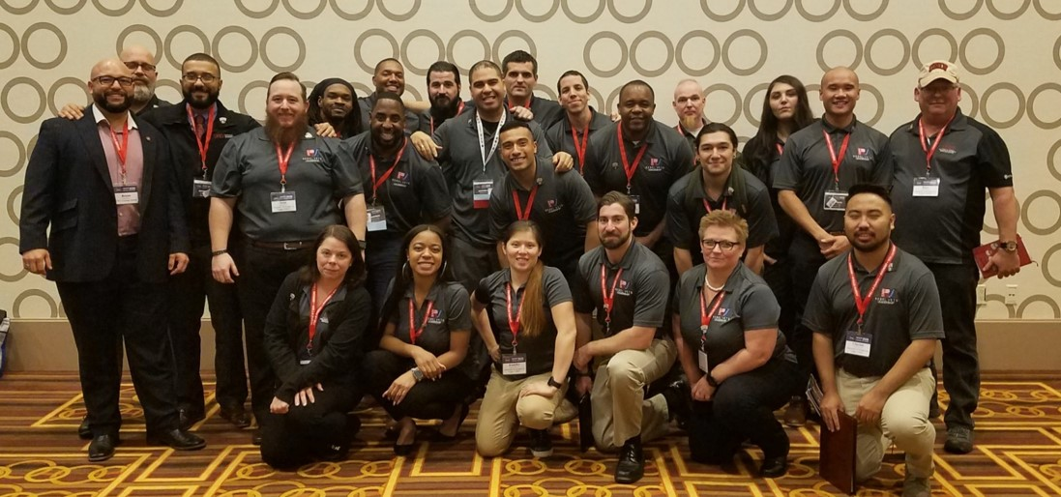

Student Veteran of America National Conference - presented on our UNLV Rebel Vet SVA and VFW partnership

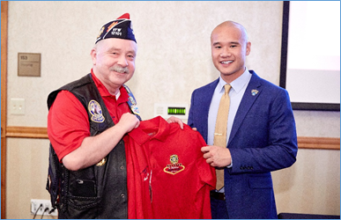

VFW POst 12101 Commander Bill Pierce awards our new Rebel Vet SVA President with a lifetime VFW membership.

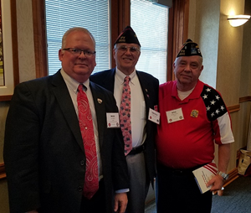

May 2019 - Rebel Vet Graduation Reception